Customizable Email Templates

Announcement Template—Monthly Discussion

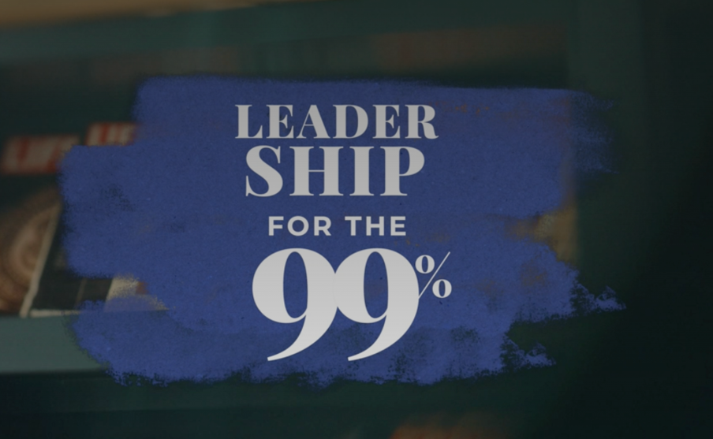

Team,

This month we’ll spend time as a team going through the Leadership for the 99% series with author Clay Scroggins on RightNow Media @ Work. I chose this series to help us learn how we can each lead from the seat we’re in and leverage our unique influence.

Over the next month, please find time to watch this four-session series on your own. In addition to watching the series, note your answers the below questions. We may not discuss every question, but I would like each person to be prepared to give your input if asked.
- [REVIEW QUESTION BANK AND INCLUDE 5-6 QUESTIONS HERE]

Please complete everything prior to [DATE], which is when we will discuss this series in our team meeting. If you haven’t registered your free RightNow Media @ Work account yet, here’s the link to do so: [INSERT CUSTOM LINK—LOG IN TO YOUR ACCOUNT, CLICK ‘SEND INVITE/CONTACTS’ IN TOP RIGHT, THEN CLICK ‘COPY INVITE LINK’ BUTTON. CONTACT YOUR CONSULTANT FOR ADDITIONAL HELP OR QUESTIONS.]

Let me know if you have any questions. I look forward to discussing this series together.

Announcement Template—Weekly Discussion

Team,

Over the next four weeks, we’ll spend time as a team going through the Leadership for the 99% series with author Clay Scroggins on RightNow Media @ Work. I chose this series to help us learn how we can each lead from the seat we’re in and leverage our unique influence.

Each week you’ll watch one session from the series and make note of your answers to the questions for that session (provided via email). We’ll then get together each week to discuss that session and the team’s responses. For our first discussion on [DATE], consider these questions as you’re watching session 1:
- [REVIEW QUESTION BANK FOR SESSION 1 AND INCLUDE TWO QUESTIONS HERE.]

If you haven’t registered your free RightNow Media @ Work account yet, here’s the link to do so: [INSERT CUSTOM LINK—LOG IN TO YOUR ACCOUNT, CLICK ‘SEND INVITE/CONTACTS’ IN TOP RIGHT, THEN CLICK ‘COPY INVITE LINK’ BUTTON. CONTACT YOUR CONSULTANT FOR ADDITIONAL HELP OR QUESTIONS.]

Let me know if you have any questions. I look forward to discussing this series together.

Reminder Template
Tip: You can reply all to your previous announcement email so your team has easy access to the questions you sent over in the original email.

Team,

Just a reminder that we’ll be discussing Leadership for the 99% with Clay Scroggins at our team meeting [next week / tomorrow].

- Make sure you’ve signed up for your free RightNow Media @ Work account: [INSERT CUSTOM LINK]
- Watch the series here (available on desktop, mobile, or TV streaming devices).
- Answer the questions I previously sent over in preparation for our discussion.

Let me know if you have any questions. I look forward to discussing this series together.

Weekly Question Email Template
Team,

For next week’s discussion, watch session [X] of the Leadership for the 99% series with Clay Scroggins on RightNow Media @ Work. Consider these questions as you’re watching:

- [REVIEW QUESTION BANK FOR THIS SPECIFIC SESSION AND INCLUDE TWO QUESTIONS HERE.]

Let me know if you have any questions. I look forward to discussing this series together.

Question Bank

From session 1:
- Many people hear the word leadership and immediately think of being in charge or being the boss. But as Clay pointed out, leadership is more than being in charge. What words or traits come to mind when you think about leadership? How has your view of leadership changed after watching this session?
- How much influence would you say you have on those around you? How much trust exists between you and the people you work with?
- In what ways have you influenced others, especially in the workplace, to make certain decisions? How have you seen the people you work with advance due to your influence?
- What habits or quirks do you have that tend to hold you back in the workplace? What could it look like for you to address these issues this week?

From session 2:
- What has been your experience with leaders who have natural talent but poor attitudes? Why do you think natural talent and skill aren’t enough to lead well?
- What personal practices do you have in place to lead yourself well?
- In order to create a plan, we have to be honest about what could work well for us and what won’t. What steps, actions, or habits could you include in your plan to lead yourself well?

From session 3:
- Clay focused on the myth that the only people in the workplace with perks are the bosses and CEOs. What assumptions have you made about your previous or current boss? What perks or advantages have you assumed that bosses receive due to their position?
- As Clay mentioned, your boss doesn’t have the same influence you do. The boss may lead the team, but you’re working alongside others, sharing in the same experiences, as you try to hit your goals. In what ways have you been able to make an influence in the workplace that is specific to the position you hold?
- What could it look like for you to take advantage of the unique perspective and influence you have in your organization this week?

From session 4:
- In this final session, Clay focused on how we can make any season one of preparation and development. You’re not wasting time just because you lack authority. In what ways have you equated a lack of authority with a wasted season?
- When we refuse to live passively, we can use our intentionality to solve problems, remain proactive, and make hard decisions. How would you describe passivity in the workplace? How could a passive attitude impact your growth as a leader?
- What’s one principle you want to take away from this series and apply to your leadership?

Tip: Additional questions can be found in the free series study guide on RightNow Media @ Work here.

